**Topics: Descriptive Statistics and Probability**

1. Look at the data given below. Plot the data, find the outliers and find out $μ, σ, σ^{2}$

|  |  |
| --- | --- |
| **Name of company** | **Measure X** |
| Allied Signal | 24.23% |
| Bankers Trust | 25.53% |
| General Mills | 25.41% |
| ITT Industries | 24.14% |
| J.P.Morgan & Co. | 29.62% |
| Lehman Brothers | 28.25% |
| Marriott | 25.81% |
| MCI | 24.39% |
| Merrill Lynch | 40.26% |
| Microsoft | 32.95% |
| Morgan Stanley | 91.36% |
| Sun Microsystems | 25.99% |
| Travelers | 39.42% |
| US Airways | 26.71% |
| Warner-Lambert | 35.00% |

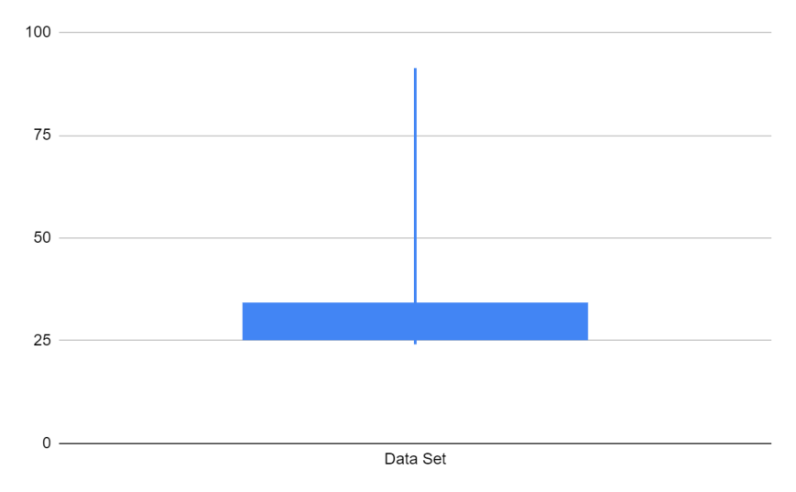

According to the box-plot created in excel, the distribution is concentrated and we have a one outlier i.e 91.36.

$μ$ = 0.332713333

$σ$ = 0.169454009

$σ^{2}$ = 0.028714661



**Answer the following three questions based on the box-plot above.**

1. **What is inter-quartile range of this dataset? (please approximate the numbers) In one line, explain what this value implies.**
2. **What can we say about the skewness of this dataset?**
3. **If it was found that the data point with the value 25 is actually 2.5, how would the new box-plot be affected?**
4. The range of inter-quartile is 11 - 5 = 6. this number gives us the spread of the major portion of data.
5. With the given box-plot, the data is positively skewed.
6. There will be no significant change in the box-plot since, our data is concentrated in between 5 to 12.



**Answer the following three questions based on the histogram above.**

1. **Where would the mode of this dataset lie?**
2. **Comment on the skewness of the dataset.**
3. **Suppose that the above histogram and the box-plot in question 2 are plotted for the same dataset. Explain how these graphs complement each other in providing information about any dataset.**
4. The mode will lie in between 5 and 6
5. The data will be positively skewed.
6. They show us the outlier and help us understand the distribution of the dataset. They help us understand if the data is normal or not.
7. **AT&T was running commercials in 1990 aimed at luring back customers who had switched to one of the other long-distance phone service providers. One such commercial shows a businessman trying to reach Phoenix and mistakenly getting Fiji, where a half-naked native on a beach responds incomprehensibly in Polynesian. When asked about this advertisement, AT&T admitted that the portrayed incident did not actually take place but added that this was an enactment of something that “could happen.” Suppose that one in 200 long-distance telephone calls is misdirected. What is the probability that at least one in five attempted telephone calls reaches the wrong number? (Assume independence of attempts.)**

Here we can use combinations to our rescue:

n=5

r=1

Probability of call getting misdirected, P = 1/200

Probability of call not getting misdirected, Q = 199/200

Probability that at least one in five attempted telephone calls reaches the wrong number=

nCr (P)n-r(Q)r = 1 - there is no misdirected call = 1 - P(0)

= 1 - ⁵C₀(1/200)⁰(199/200)⁵⁻⁰ = 1 - (199/200)⁵ = 0.02475

1. **Returns on a certain business venture, to the nearest $1,000, are known to follow the following probability distribution**

|  |  |
| --- | --- |
| **x** | **P(x)** |
| **-2,000** | **0.1** |
| **-1,000** | **0.1** |
| **0** | **0.2** |
| **1000** | **0.2** |
| **2000** | **0.3** |
| **3000** | **0.1** |

1. **What is the most likely monetary outcome of the business venture?**
2. **Is the venture likely to be successful? Explain**
3. **What is the long-term average earning of business ventures of this kind? Explain**
4. **What is the good measure of the risk involved in a venture of this kind? Compute this measure**
5. The most likely monetary outcome will be $2000 since it has the highest probability of 0.3.
6. When we calculate the expected values or even have a look at the table. We can see that -2000 to 0 the sum of the probabilities is 0.4 while in the range of 1000 - 2000 as returns the sum of probability is 0.5. therefore, the venture is likely to be successful.
7. We can calculate the expected values as shown below:



We can conclude that the measure of the risk involved is expected values an since it is positive it is a good investment..